My 4-H
Cloverbud
Record Book

Paste a photo of you here.
Include your name below your picture.

Table of Contents

Roosevelt County 4-H Cloverbud Report Form

Having Fun as a Cloverbud

Cloverbud Project Photos

Cloverbud Activities

Helping My Community

Cloverbud Fair Exhibits

Cloverbud Project Activity Sheets (Maximum of 10 from up to 4 projects)


Roosevelt County
Cloverbud Report Form

Current 4-H Year: ___________ Date of Birth:_____________________
My name is ______________________________________________________

My address is____________________________________________________

I am __________years old. I am in the ______________________ grade.

I belong to the _________________________________________4-H Club.

This Year My Cloverbud Projects Were: (Maximum of 4)

1._________________________________________________________________

2._________________________________________________________________

3._________________________________________________________________

4._________________________________________________________________



STATEMENT BY CLOVERBUD MEMBER

I have personally prepared this record book about my 4-H project work.

Date:____________ Signature of 4-H Member_________________________________

APPROVAL OF RECORD BOOK

Date:____________ Signature of Parent/Guardian_____________________________

Date:____________ Signature of 4-H Leader___________________________________
This year I had fun doing…
Draw a picture or paste a photo of you having fun being a 4-H Cloverbud member.

Write a short story about having fun being a Cloverbud.
____________________________________________________________________________________________________________________________________________________________________________________________________________________________________________________________

These are pictures of me working on my 4-H Cloverbud projects:

Paste pictures here. Be sure to label each picture with a caption.

Look at My Cloverbud Activities…
Draw a picture or paste a photo of a favorite Cloverbud or 4-H club activity. Label your picture or photo.

.

What did you learn?
________________________________________________________________________________________________________________________________________________________________________________________________________________________

Look at me; I’m helping my community…
Draw a picture or paste a photo of you helping your community. Label your picture.

Write a short story about helping your community.
____________________________________________________________________________________________________________________________________________________________________________________________________________________________________________________________

Look at my Cloverbud Exhibits at the Fair…
Paste photos of your Cloverbud fair exhibits here. Be sure to label photos.

4-H Cloverbud Project
Activity Sheets
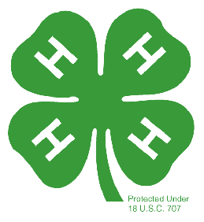
Look at all the work I’ve done this year!

Place up to 10 from no more than 4 projects of your favorite 4-H Cloverbud project activity sheets from your project books in this section.
Use dividers between each project area.

